# SDL MINI PROJECT REPORT

**ON**

**FEEDBACK SYSTEM**

**Submitted By:**

**Akshay Chavan**

**Ashutosh Bhawsar**

**Aabid Agharia**

**Branch : T. E. Computer (2017-2018)**

**Guided By: Prof.D.M.Kanade**

**Department of Computer Engineering**

**K. K. Wagh Institute of Engineering Education & Research**

**Hirabai Haridas Vidyanagari, Amrutdham, Panchavati,**

**Nashik – 422 003.**

**Affiliated to**

**Savitribai Phule Pune University**

**K. K. Wagh Institute of engineering education & research**

**NasHik.**

***CERTIFICATE***

This is to certify that

**Akshay Chavan**

**Ashutosh Bhawsar**

**Aabid Agharia**

Has Successfully completed

SDL Mini Project on

FEEDBACK SYSTEM

Towards the Partial Fulfilment Of Bachelor’s

Degree In Computer Engineering

Of Savitribai Phule Pune University

During Academic Year 2017 – 2018

|  |  |  |
| --- | --- | --- |
| **Prof.D.M.Kanade** | **Prof.Dr. S. S.Sane** | **Prof. Dr. K. N. Nandurkar** |
| [Mini Project Guide] | [H.O.D] | [Principal] |

**ABSTRACT**

Student feedback system is the feedback collecting system from the students and provides the automatic generation of a feedback which is given by students. We have developed student feedback system to provide feedback in a quick and easy manner to the particular department. So we called it a student’s feedback system which delivers via the student staff interface as system which acting as a service provider. By using this technology we can give feedback in the system as fast as compare to the existing paper feedback system.

The existing system carries more time to do a piece of work for this reason the software system feedback is implemented. Students will fill feedback using a standard form. In this project security is also maintain that is the result of feedback is only visible to authentic user.

INTRODUCTION

The Student Feedback System is a management information system for education establishments to manage student data. Student Feedback Systems provide capabilities for selecting particular subject for feedback and generate the report automatically in a college. A Student Feedback System is an automatic feedback generation system that provides the proper feedback to the teachers as per the categories like always, poor, usually, very often, sometimes.

In the existing system students can give feedback about the lecturers by doing manually. By this process student can give feedback in system without wasting his time in writing. After giving feedback by every student papers are collected by the faculty and calculated the overall grade for each subject and each lecturer. After that those all grade report is viewed by the HOD which is given by the faculty. Hence estimating the performance of lecturers and giving feedback to college staff. So, the existing system carries more time to do a piece of work for this reason the online system feedback is implemented. This is the main disadvantage of the existing system for giving feedback about the lecturers and viewing report of lecturers manually. Student feedback on courses is an essential element in quality assurance.

Questionnaires are of primary importance in the dialogue with students, since they are the best tool we currently have for collecting objective, detailed and reasonably systematic information on a wide range of questions, which Informs the teacher about student’s perceptions of the course's strengths and weaknesses. Responses are collated on behalf of departments by the system, and will be used only for the purposes of quality enhancement.

In order to gain maximum advantage:

Students should be told how the feedback will be submitted, when and how the results will be published, and that their contribution is important and taken seriously.

The Head of Department should discuss a dispassionate summary of the feedback on each course with the lecturers concerned.

SCOPE

1) Decision making power is provided by this system.

2) Accurate result can be obtained.

3) This system makes Selection process more effective

4) To increase efficiency proposed system is depend on classification method.

5) Proposed system is used to reduce confusion at the time of processing feedback average.

REQUIREMENTS

1. Functional Requirements:
2. JDK
3. 100MB of free space
4. Operating system: Windows 7 or newer/Ubuntu 14.04 or newer
5. Non-Functional Requirements:
6. Student/Teacher/HOD Login Information
7. Sufficient knowledge for genuine feedback.

USE CASE DIAGRAM

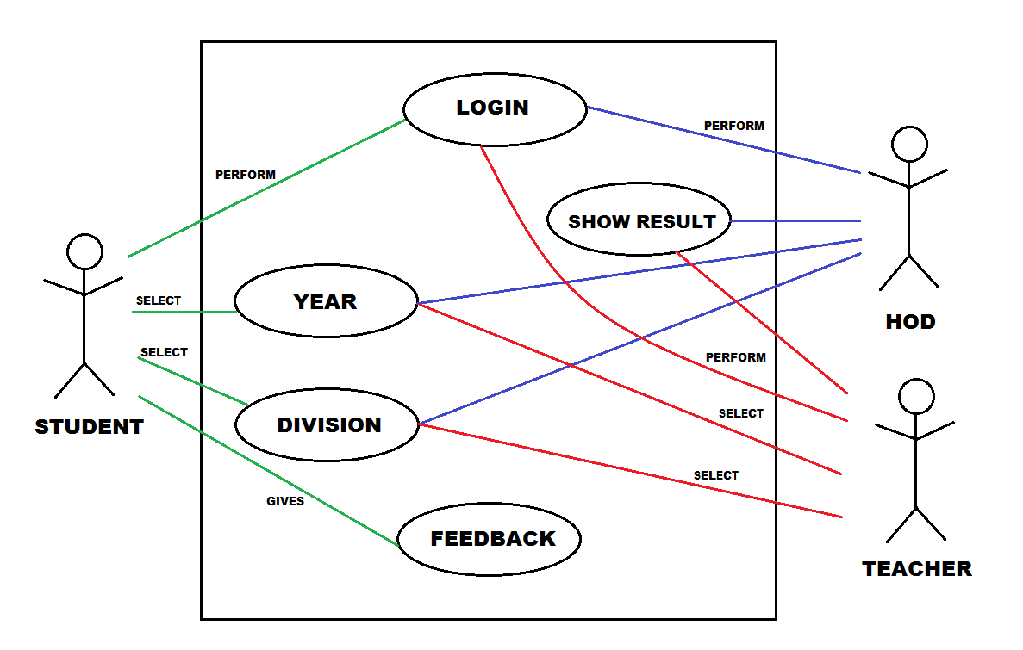

IMPLEMENTATION

DEPLOYMENT DIAGRAM –

**TCP/IP**

**USER INTERFACE**

**FEEDBACK**

**APPLICATION**

**<<DATABASE>>**

**FEEDBACK**

**CLIENT**

**SERVER**

PROPOSED WORK

The main objective was to create a unique and useful “student feedback system” with exceptional quality and services that differentiates it from other system. The key feature of the element of this system is:

• Database

• Functions

Users are broadly classified into 4 categories:

1. Admin

2. Student

3. Faculty

The core functionality that is to be included in the system is as follows:

4.1 Admin

• Can insert/update/delete new student (But, Not Feedback).

4.2 Student

• Can select the marking criteria.

• Can give the comments/compliments to the respective staff members.

4.3 Faculty

• Can view their respective comments/compliments given by students.-

• Can view total evaluated feedback.

CONCLUSION

This project is design for the purpose to reduce the lecturer’s time and to reduce the burden of maintaining huge amount of records of students. At the time of feedback generation it apply formulae for generate a feedback of particular subject. After that it will displayed the whole record sheet to the staff, when the staff will login in the system. As the comparison with Manuel feedback or existing feedback system the new system is easier way to manage whole things in a particular manner. As per the existing system it is very easy process to save each and every record of individual student by the use of database.

REFERENCES

* [www.wikipedia.com](http://www.wikipedia.com)
* JAVA-THE COMPLETE REFERENCE by HERBERT SHIELDT.
* [www.tutorialspoint.com](http://www.tutorialspoint.com)
* [www.stackoverflow.com](http://www.stackoverflow.com)